*Florida International University*

*School of Computing and Information Sciences*

Software Engineering Focus

Feature Document

User Story ID <787>

**Name: Mairim Barrios**

**Team Member(s):**

**Project: AR-VR-VE Computer Science**

**Product Owner(s)**: Francisco Ortega

**Mentor(s)**:

**Instructor**: Masoud Sadjadi

User Story ID <787>

**User Story Name: Add and adjust an additional camera into the main screen**

* Description: **As a user I wan to to see both the UI and the maze on the same screen so that I can see what commands I should choose for my solution**

Acceptance Criteria

* Maze and main cameras act independently of each other even when they are on the same screen.

**Use Case**

* Name: User is on the scene thinking about the solution
* Actor: Player
* Preconditions: User has started level 1
* Description <The player has chosen to play a level of the game, he has walked through the tutorial for that level and is ready to begin. He sees the maze on a small window within the screen. >:

**Use Case Diagram**

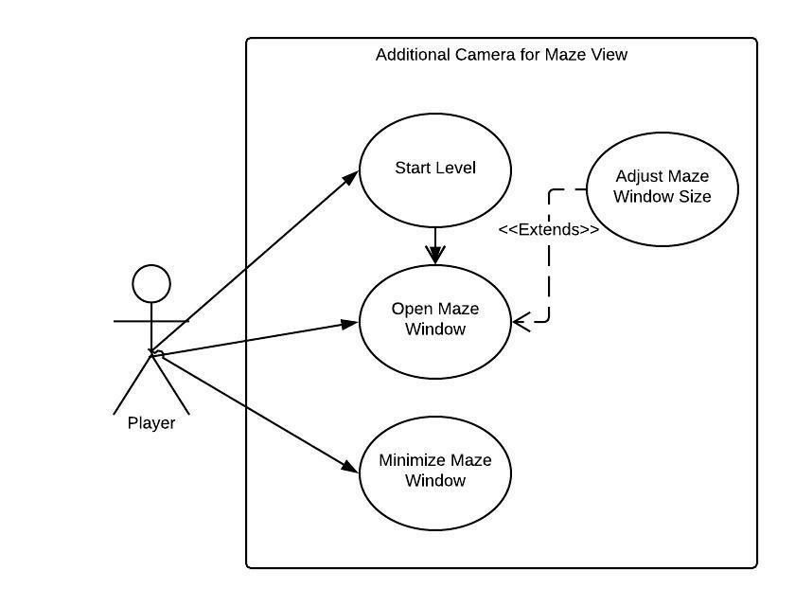

**Sequence Diagram**

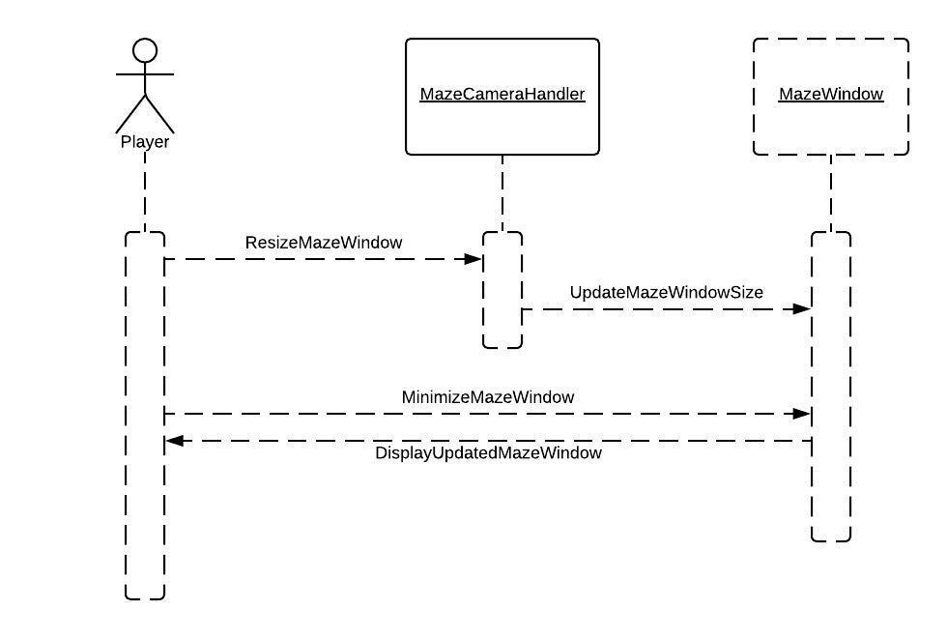

**Class Diagram**

